**E BOOK MANAGEMENT SYSTEM:**

***Use case diagram****:*

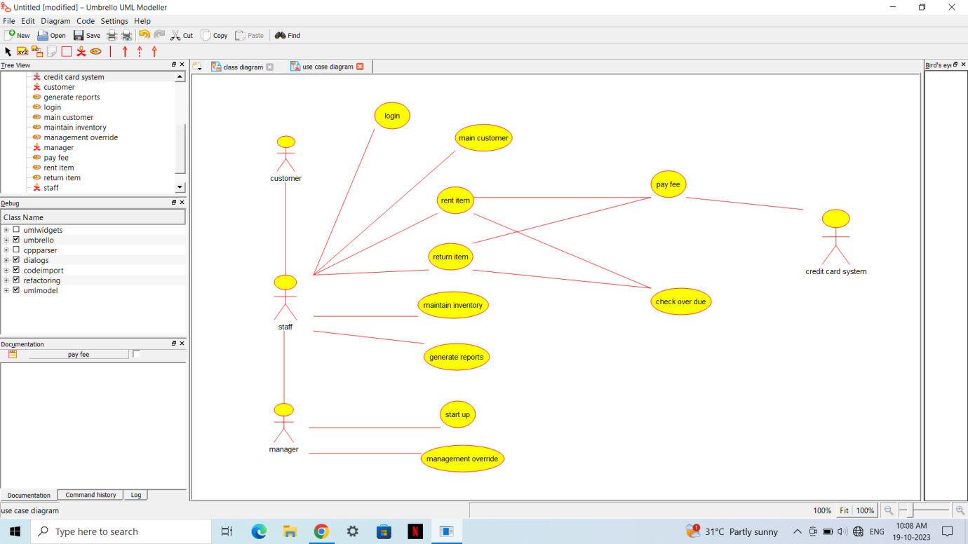

***Class diagram:***



***Activity diagram:***



***Collaboration diagram:***



***Deployment diagram:***



***Component diagram:***

